**Module-6: Ansible Assignment - 1**

*Tasks To Be Performed:  
1. Setup Ansible cluster with 3 nodes  
2. On slave 1 install Java  
3. On slave 2 install MySQL server*

Launch 3 Instances in AWS and add Tags as Ansible-Master, Ansible-Slave1, ansible-slave2

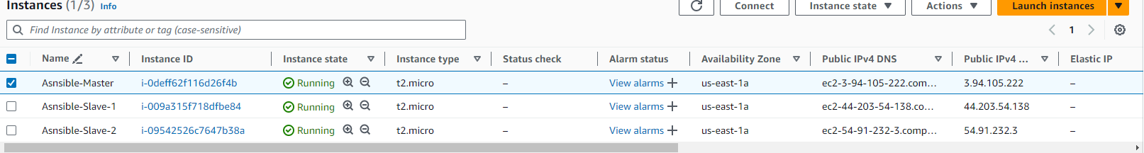

Connect with all the three Instances

Install Ansible on Master Instance (Ansible-Master)

[Installing Ansible on Ubuntu](https://docs.ansible.com/ansible/latest/installation_guide/installation_distros.html#id5)

sudo apt update  
sudo apt install software-properties-common  
sudo add-apt-repository --yes --update ppa:ansible/ansible  
sudo apt install ansible

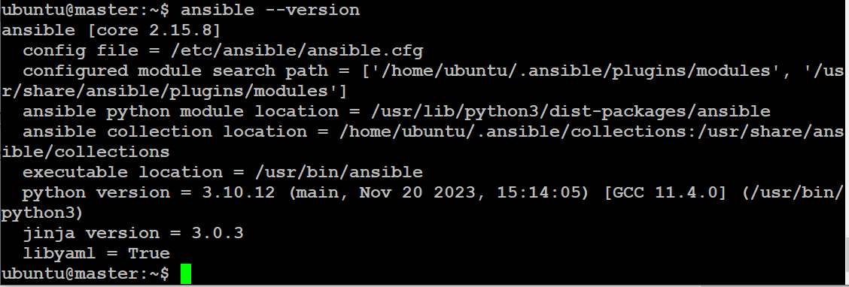

Now we need to create a connection b/w master and slaves1,slave2

for the connection, we need to generate a keypair in master and pasting the keypair will help us to connect with slave1,slave2

ssh-keygen (Ansible-M)

key will be saved in :

/home/ubuntu/.ssh/id_rsa.pub

copy the key from the Ansible-M and past it in “.ssh/authorized_keys” file

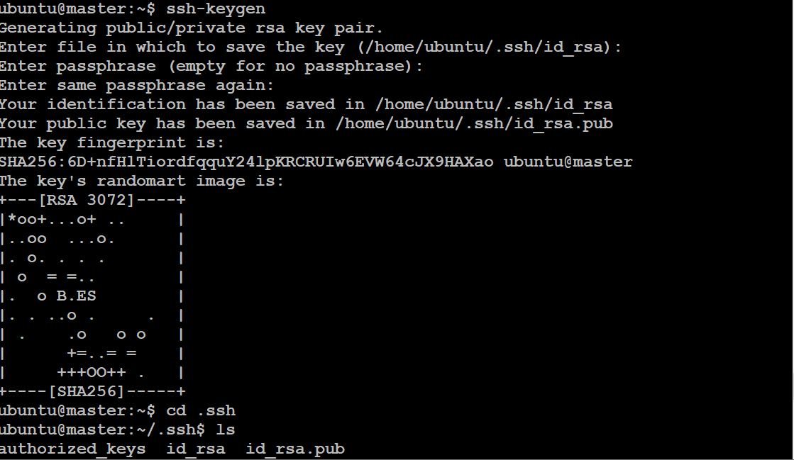

Ansible-Master



Ansible-Slave1



Ansible-Slave2



we need to add the slave Private-IP into the ansible host file

path of the ansible host file: cd /etc/ansible/

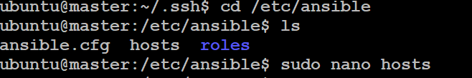

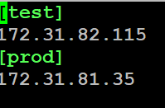

to check whether the connection is successful or not

ansible -m ping all

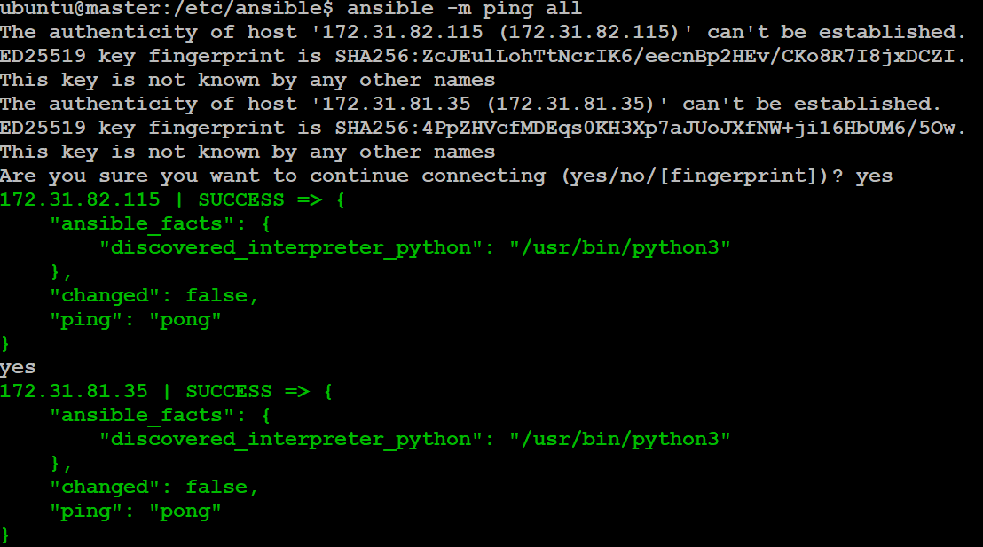

sudo nano assign1.yml

---

- name: installing java

  hosts: test

  become: true

  tasks:

  - name: java

    apt: name=openjdk-11-jdk state=latest

- name: installing Mysql

  hosts: prod

  become: true

  tasks:

  - name: mysql

    apt: name=mysql-server state=latest

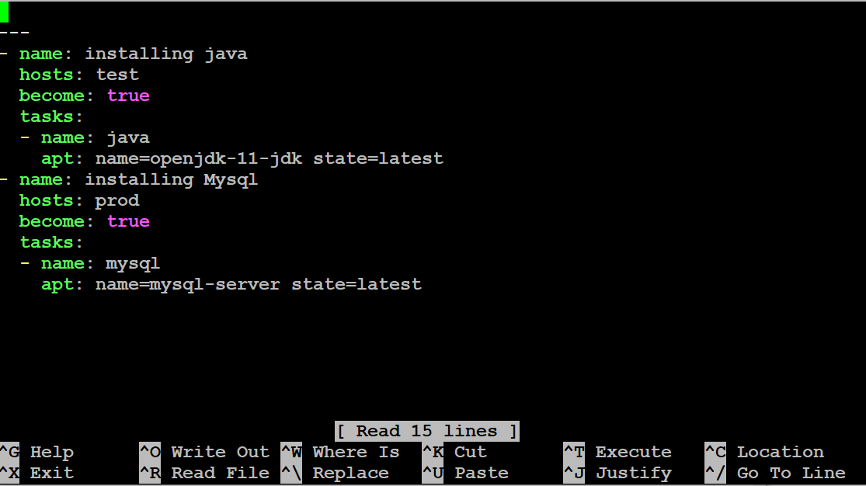

this file is used for installing Java in Salve 1 which is test as the group name and MySQL and Slave 2 which is prod as the group name.

ansible-playbook assign1.yml -- syntax-check (to check the syntax of the file)

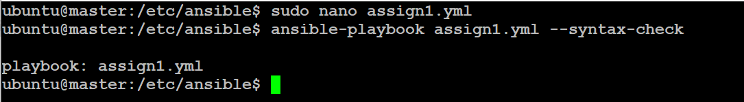

ansible-playbook assign1.yml -check (Trail run)

ansible-playbook assign1.yml

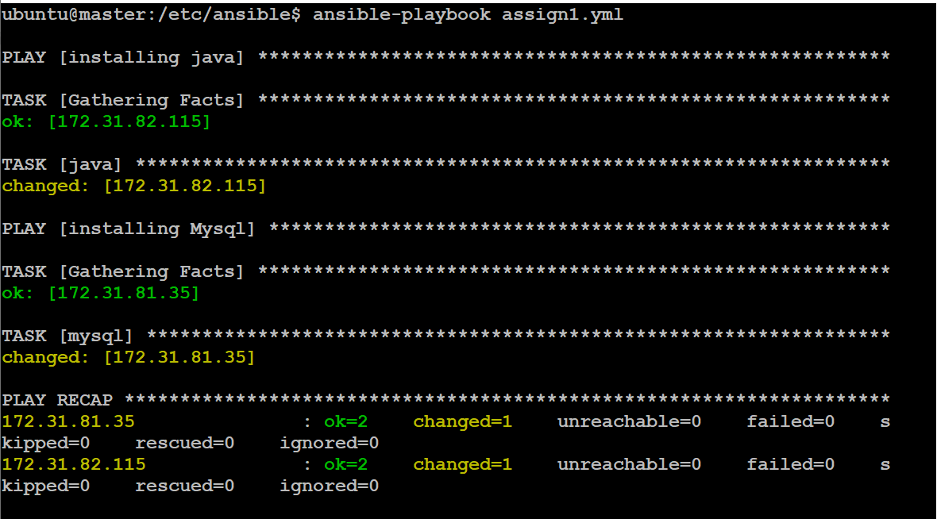

Check on slave1

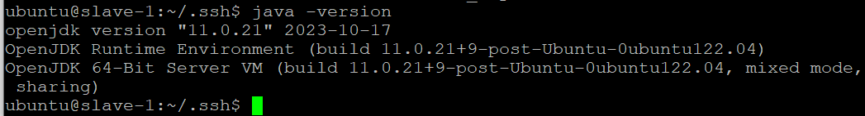

Check on slave2



**Module-6: Ansible Assignment – 2**

You have been asked to:

● Create a script which can add text “This text has been added by custom script” to

/tmp.1.txt

● Run this script using Ansible on all the hosts

sudo nano assign2.sh (It creates a shell script)

echo “This text has been added by custom script” > /tmp/1.txt

bash assign2.sh ( to execute the script file )

2. Run this script using Ansible on all the hosts

sudo nano assign2.yml

---

- name: copy txt

  hosts: all

  become: true

  tasks:

    - name: script

      script: assign2.sh

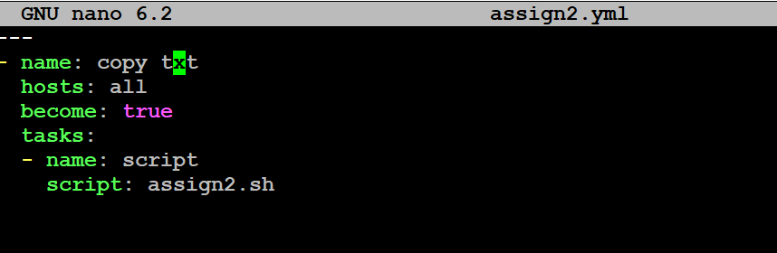

the above script is used for copying the files

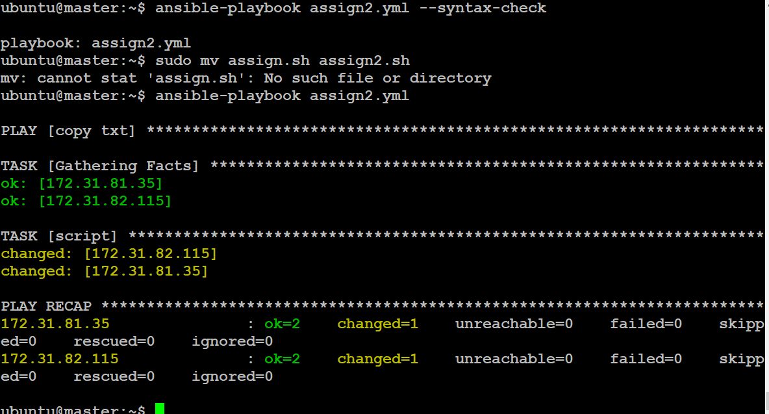

checked in Slave1

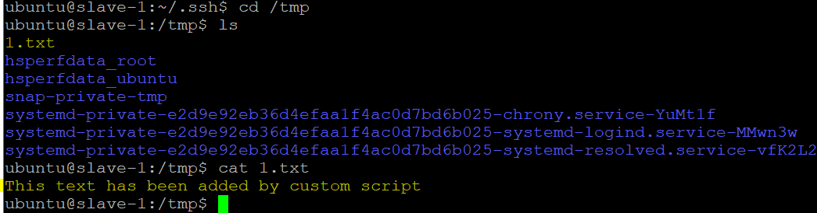  
checked in Slave2

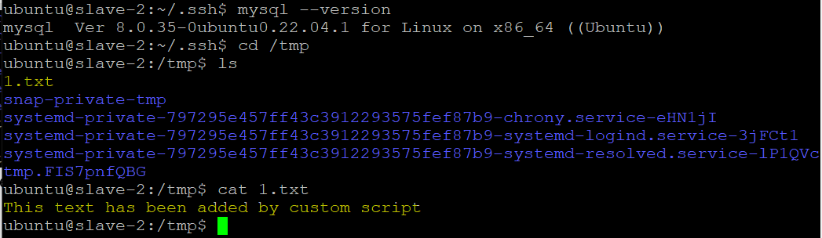

**Module-6: Ansible Assignment – 3**

Tasks To Be Performed:  
1. Create 2 Ansible roles  
2. Install Apache2 on slave1 using one role and NGINX on slave2 using the other role  
3. Above should be implemented using different Ansible roles

1. *Create 2 Ansible roles*

To create ansible roles:

Go inside the directory cd /etc/ansible/roles

sudo ansible-galaxy init apache2

sudo ansible-galaxy init nginx

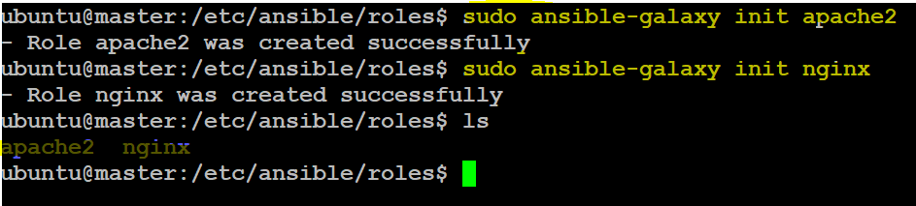

*2. Install Apache2 on slave1 using one role and NGINX on slave2 using the other role*

path of Ansible Apache role

cd /etc/ansible/roles/apache2/tasks/

path of Ansible nginx role

cd /etc/ansible/roles/nginx/tasks/

add the yml playbook files inside tasks

*---*

*- name: apache2  
apt: name=apache2 state=latest*

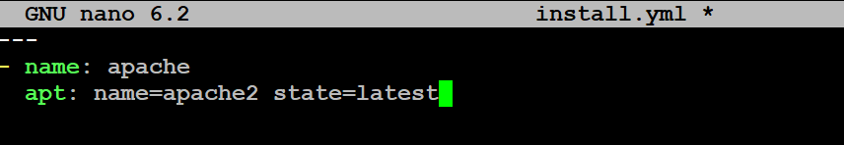

*sudo nano main.yml*

*---  
- include_tasks:install.yml*

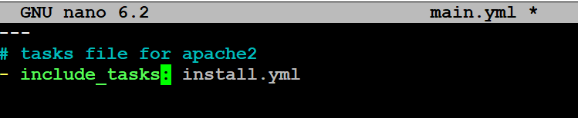

*---*

*- name: nginx  
apt: name=nginxstate=latest*

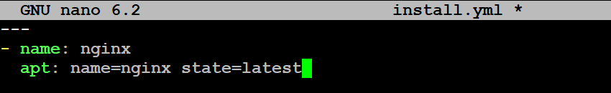

*sudo nano main.yml*

*---  
- include_tasks:install.yml*

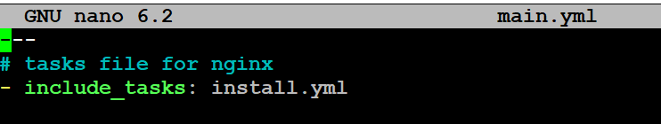

finally create a playbook to execute the tasks of the role

sudo nano assign3.yml

---

- name: installing apache2

  hosts: test

  become: true

  roles:

  - apache

- name: installing nginx

  hosts: prod

  become: true

  roles:

  - nginx

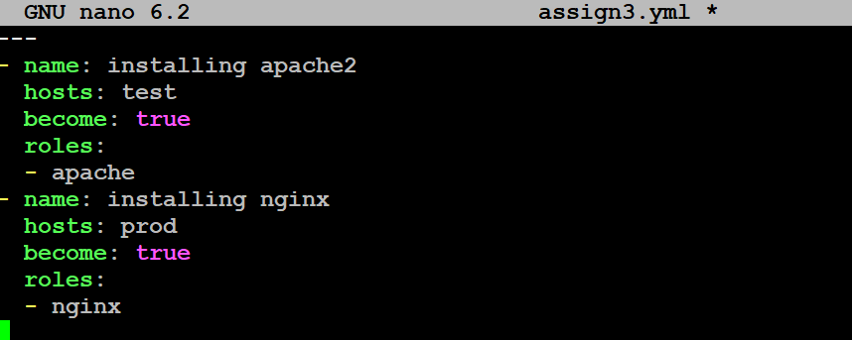

ansible-playbook assign3.yml (to execute the ansible playbook)

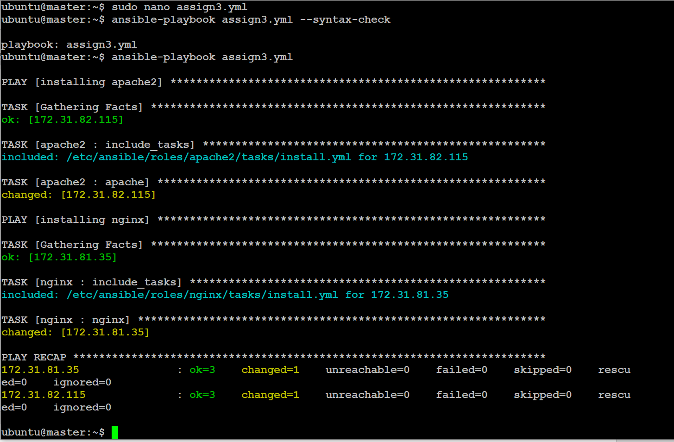

Now we will be checking the webservers

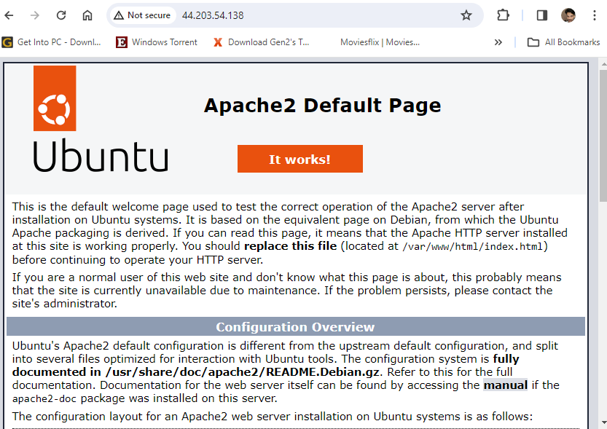



**Module-6: Ansible Assignment – 4**

**Tasks To Be Performed:**  
1. Use the previous deployment of the Ansible cluster  
2. Configure the files folder in the role with index.html which should be replaced with the original index.html  
All of the above should only happen on the slave which has NGINX installed using the role.

1. *Use the previous deployment of the Ansible cluster  
   2. Configure the files folder in the role with index.html which should be replaced with the original index.html*

go to cd /etc/ansible/roles/apache2/files

create an index.html

<h1>Hi $Hello World</h1>



go to cd /etc/ansible/roles/apache2/tasks

and create a new file which is copy.yml

---

- name: copy index.html

  copy: src=/etc/ansible/roles/apache2/files/index.html dest=/var/www/html

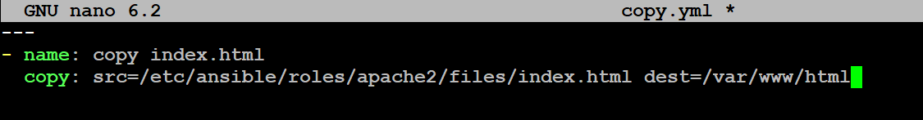

include the copy.yml file in the main.yml

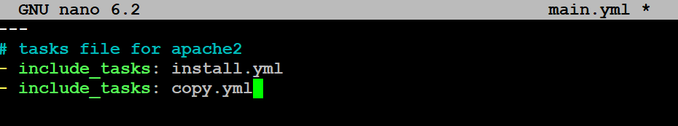

go to cd /etc/ansible/roles/nginx/files

create an index.html

<h1>Hi $hello world2</h1>

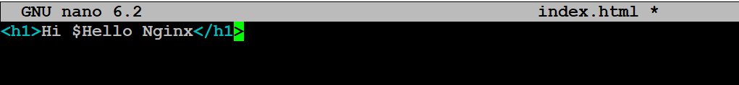

go to cd /etc/ansible/roles/nginx/tasks

and create a new file which is copy.yml

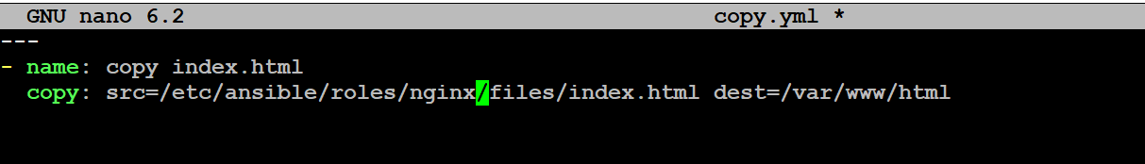

include the copy.yml file in the main.yml

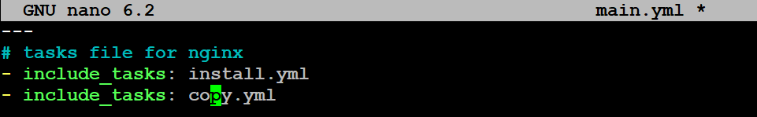

Create playbook for assign4

sudo nano assign4.yml

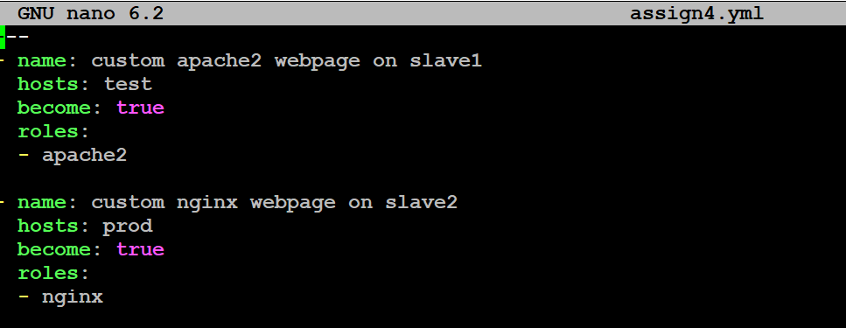

run the play book

ansible-playbook assign4.yml

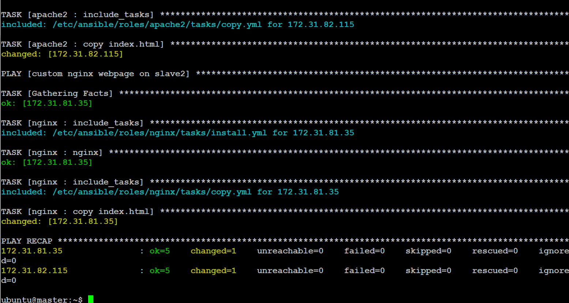

Apache server



Nginx server



**Module-6: Ansible Assignment – 5**

**Tasks To Be Performed:**  
1. Create a new deployment of Ansible cluster of 5 nodes  
2. Label 2 nodes as test and other 2 as prod  
3. Install Java on test nodes  
4. Install MySQL server on prod nodes

***Tasks To Be Performed:*** *1. Create a new deployment of Ansible cluster of 5 nodes  
2. Label 2 nodes as test and other 2 as prod  
3. Install Java on test nodes  
4. Install MySQL server on prod nodes*

Launch 2 more instance slave-3, slave-4

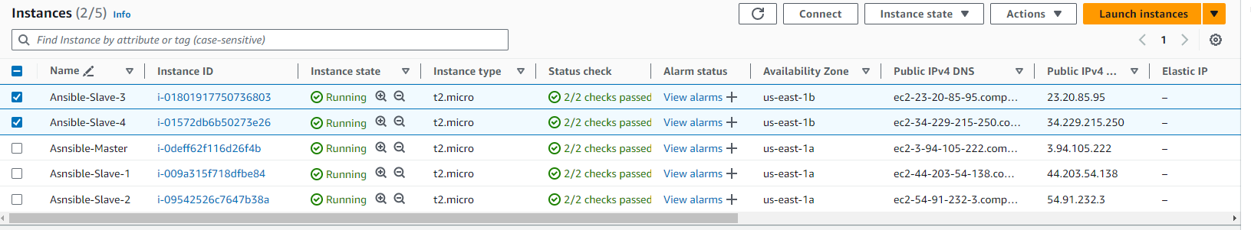

Edit authorized_keys

And paste id_rsa.pub inside the authorized_keys

Slave 3



Slave 4



Create entry in /etc/ansible/hosts file

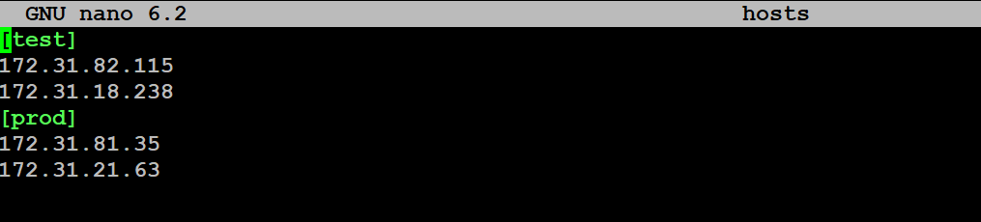

Check weather all hosts connected or not

ansible -m ping all

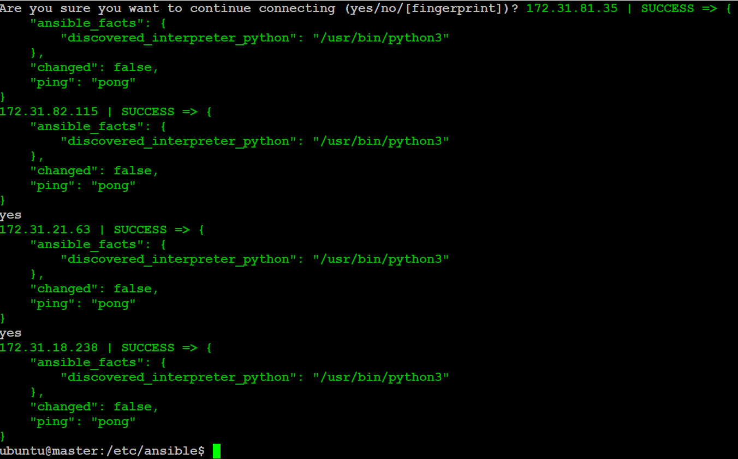

To create ansible roles:

now we need to create roles in ansible

go inside the directory cd /etc/ansible/roles

sudo ansible-galaxy init java

sudo ansible-galaxy init mysql

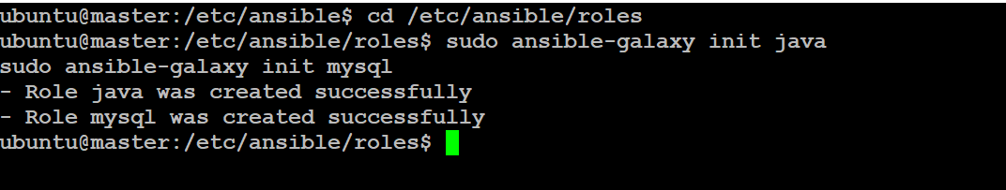

create an install.yml file in cd /etc/ansible/roles/java/tasks

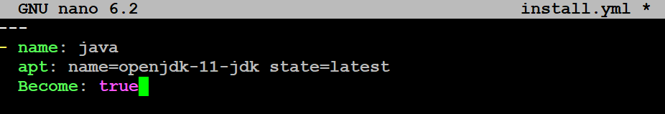

add the install.yml to main.yml

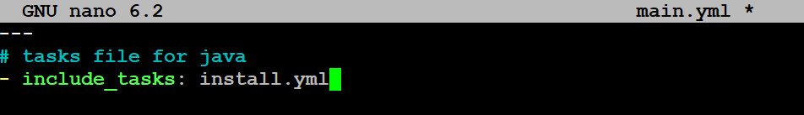

main.yml

create an install.yml file in cd /etc/ansible/roles/mysql/tasks

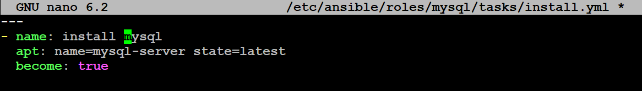

install.yml

add the install.yml to main.yml

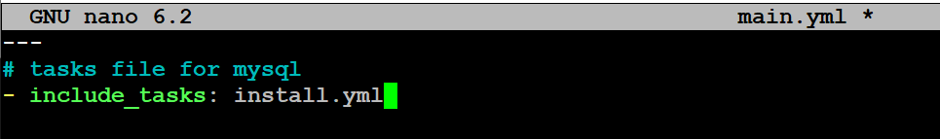

main.yml

write a assign5.yml file to install java in prod and Mysql in test

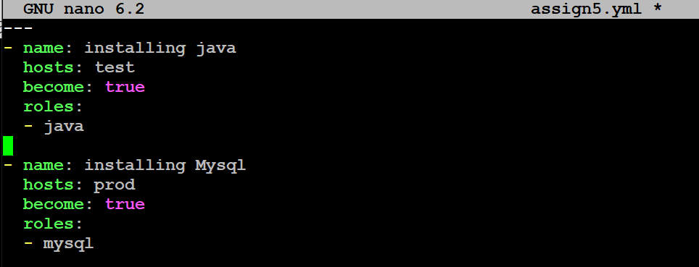

Apply assign5.yml

ansible-playbook assign5.yml --syntax-check

ansible-playbook assign5.yml

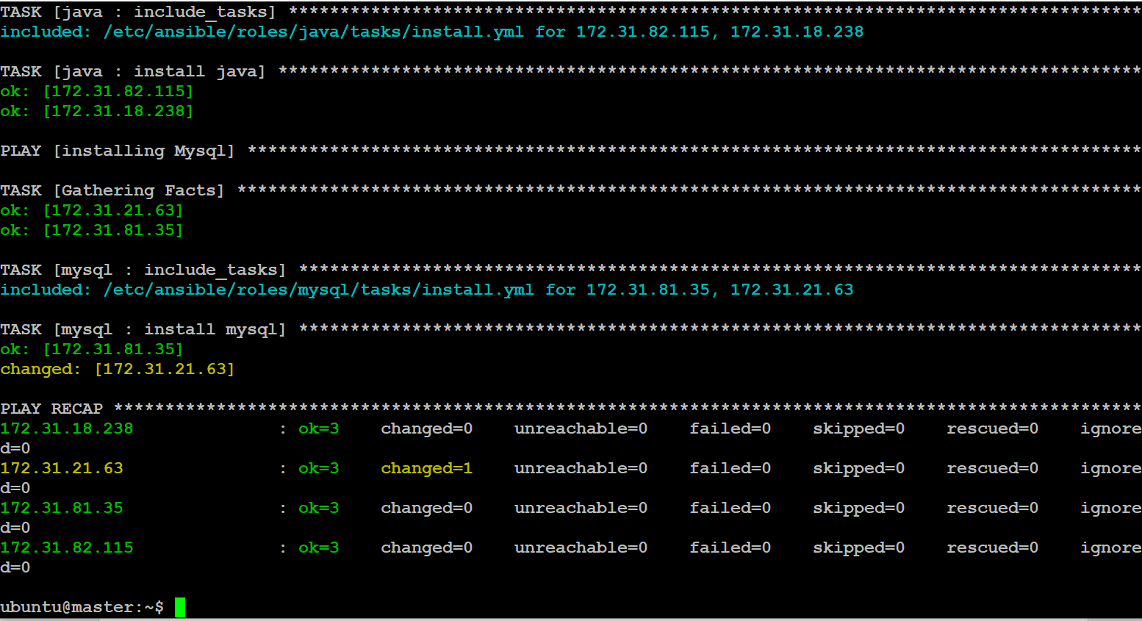

Veryfie slave-3 java

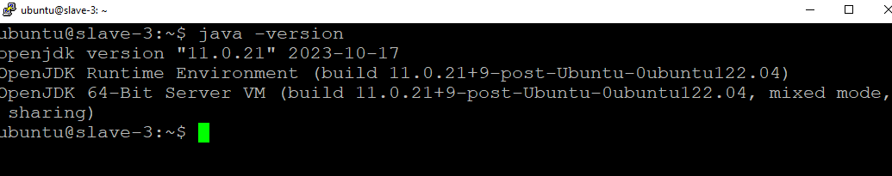

Veryfie slave-4 mysql

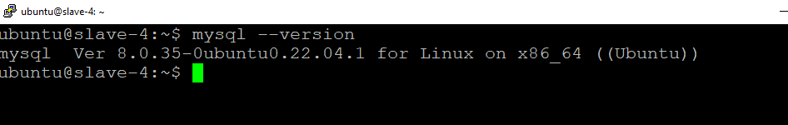

We have succsesfull perfrom all assignments tasks: